Planning & Design
Emerald POS Systems
Kaehil Indurjeeth
PROG7311 Emeris
System Overview
Emerald POS Systems serves as a centralized digital platform to manage restaurant operations including order processing, sales transactions, table bookings, kitchen workflow, inventory monitoring and administrative reporting.
The aim of this system is to replace manual, time-consuming processes with a scalable, secure, and integrated solution that improves efficiency, and provides live business insights.
The platform supports multiple user roles:
- Waitrons
- Kitchen Staff
- Administrators
- Hosts/Hostesses
The system will operate as a web-based application with central data storage and role-based access control.

Target Users
User Type | Description | Needs
Waitrons | Front-of-house staff | Quick order entry, modify orders, generate receipts
Kitchen Staff | Back-of-house staff | View live orders, update preparation status
Admin | Management role | View reports, manage staff, stock monitoring
Host/Hostess | Booking manager | Allocate tables and manage reservations
Restaurant Owner | Strategic oversight | Sales analytics, performance monitoring.

System Scope
Included in Scope | Excluded from scope (currently)
- Order creation and modification  - Sales and invoicing system  - Kitchen dashboard  - Booking management  - Admin dashboard  - Stock viewing  - Staff management  - Role-based authentication  - Reporting and analytics | - Hardware integration (Speedpoints)  - Payroll automation  - Mobile customer loyalty and review app  - Multi-location synchronisation

System Characteristics
Scalability
The system will:
- Support incrementing numbers of orders simultaneously
- Be designed using modular architecture. Separate models for sales, bookings, the kitchen etc.
- Allow future extension to:
  - Mobile interfaces
  - Cloud hosting
  - Multiple branches
- Use:
  - Database indexing for performance
  - Three-layered architecture
  - RESTful API structure for future integrations

Maintainability
The system will:
- Follow SOLID principles
- Use MVC architecture
- Have clearly defined nodes per team member
- Use separation of concerns
- Use GitHub version control for collaborative development

Security
Security measures:
- Role-based access control (Admin, waitron, kitchen, host).
- Encrypted passwords (hashing)
- Secure authentication session management
- Logging of critical actions (deleting bookings, closing bills)
Integration
The system will be designed for:
- Future payment gateway integration (Zapper, PayPal)
- Inventory supplier system integration
- Accounting software integration
- API-based architecture for external systems

Functional vs Non-functional Requirements
Functional Requirements | Non-functional Requirements
- The system must allow waitrons to create and modify orders.  - The system must generate invoices and receipts.  - The system must allow kitchen staff to update order status.  - The system must allow admins to manage staff and stock.  - The system must allow booking management and table allocation.  - The system must calculate total sales and generate analysis reports. | - The system must respond within two seconds for order creation.  - The system must support at least 50 concurrent users.  - The system must ensure 99% uptime.  - The system must protect all user passwords using encryption.  - The system must be user-friendly and require minimal training.

Individual Functional Contributions
Kaehil Indurjeeth (ST10438880) – Order Creation Module
Functional Requirement:
The system must allow waitrons to create, modify, and cancel customer orders using a dynamic button-based interface categorized by food types.
Justification:
Critical to restaurant operations. Ensures structured order input that reduces the chance of human error.
System integration:
- Core transaction-processing component
- Connects to Sales System and Kitchen Dashboard
- Uses business logic layer for price calculation and validation
- Follows modular architecture

Diya Lakha (ST10439176) – Sales System
Functional Requirement:
The system must generate invoices, calculate totals, and format receipts for completed orders
Justification:
Financial accountability and transaction accuracy are essential for business environments.
System Integration:
- Integrated with Order Creation Module
- Supports analytics and report generation
- Implements financial data sensitivity protection measures
- Designed to incorporate payment gateway integration in future

Gregory Luyckfasseel (ST10441344) – Booking & Authentication System
Functional Requirement:
The system must allow table bookings, prevent double booking, and authenticate users via secure login.
Justification:
Guarantees structured customer flow and controlled system access.
System Integration:
- Uses database constraints to prevent conflicts
- Integrates with Admin and Host roles for table allocation
- Implements role-based security model.

Zario Di Paolo (ST10441349) – Admin Dashboard
Functional Requirement:
The system must provide administrators with access to stock levels, staff management, total sales and live monitoring.
Justification:
Provides strategic oversight and operational control.
System Integration:
- Central management layer
- Compiles data from multiple modules
- Supports business intelligence functionality
- Designed for scalability into business analytics

Kyra Naidoo (ST10448414) – Kitchen Dashboard
Functional Requirement:
The system must allow real-time updates to a kitchen dashboard that displays incoming orders, their details, and the status of preparation.
Justification:
Ensures efficient communication between front-of-house and kitchen staff, reduces order delays, and improves workflow visibility. This minimizes preparation errors and enhances the overall smoothness of operations.
System Integration:
- Core operational workflow component
- Integrates directly with the Order Creation Module
- Sends status updates to the Sales and Admin modules
- Uses real-time data synchronization
- Designed to scale across multiple branches

System Architecture (unfinished)
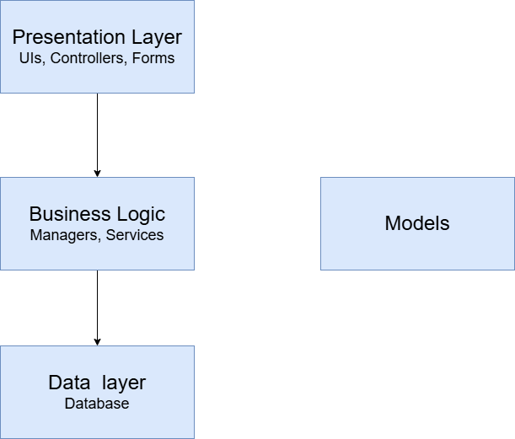

UI Design
The following mock-ups detail how the user interface will be constructed and serve as a basis for future development.
Login Portal
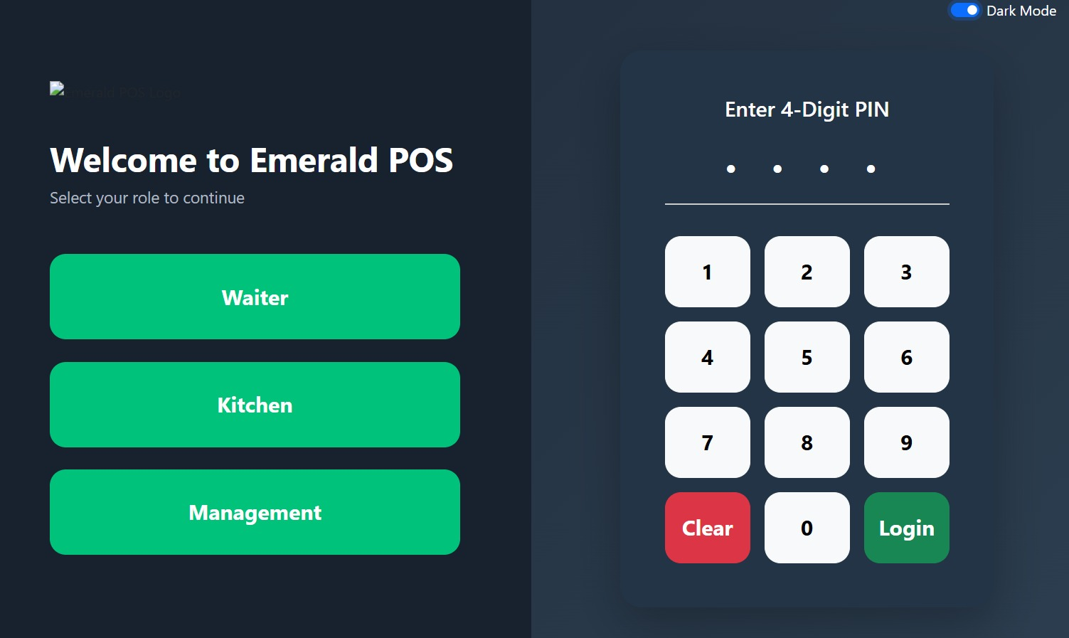
Login Portal – Dark

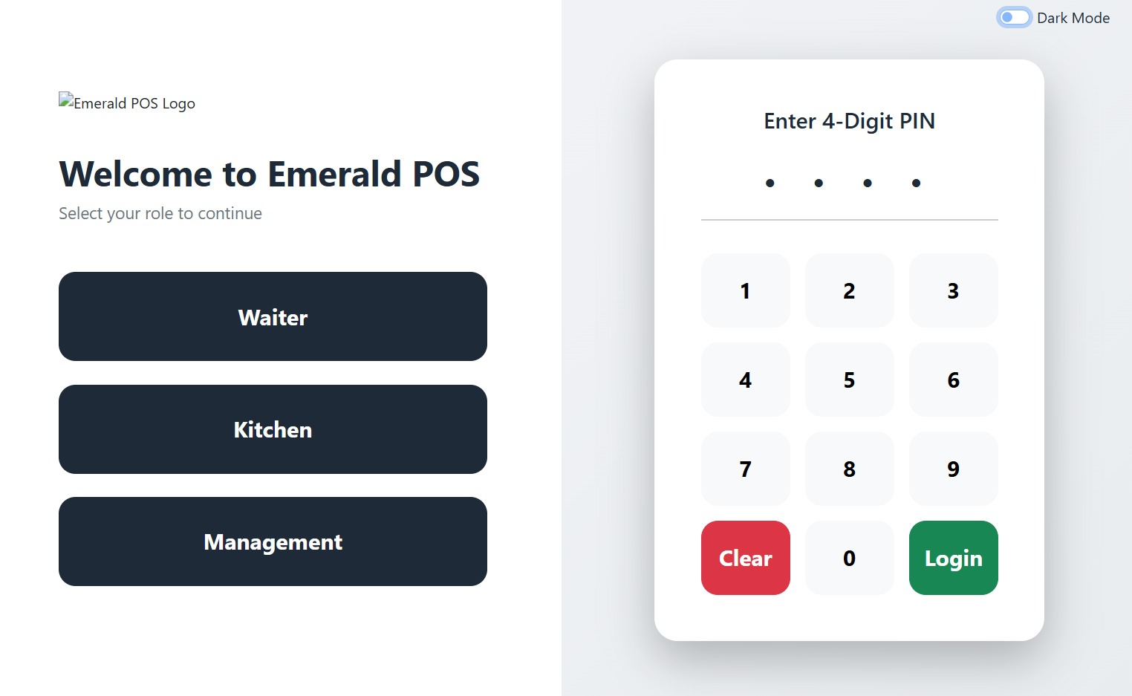
Login Portal – Light
Key Features
- Buttons to select role have been enlarged with speed and efficiency in mind.
- A 4-digit pin will be used for user authentication as this provides a secure form of access control whilst ensuring staff working under pressure are not inhibited by a tedious login process.
- Colour-coded “Clear” and “Login” buttons allow for increased efficiency.

Waitron Portal
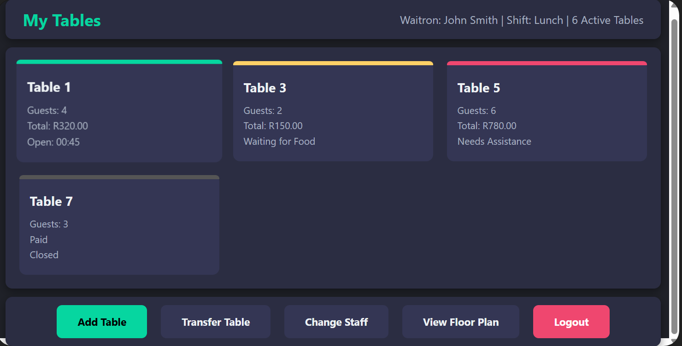
Waitron Portal – Table Overview
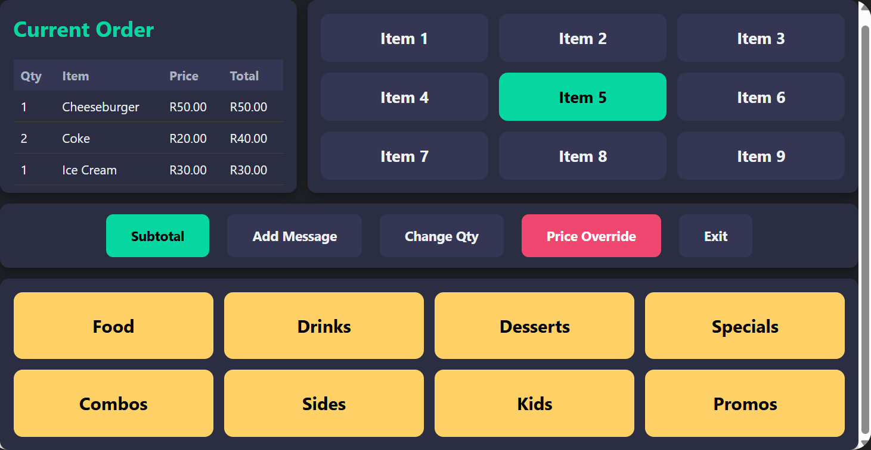
Waitron Portal – Order Creation
Key Features:
- Table Overview displays a minimalist interface containing important information for waitrons.
  - Header bar displays their name, what shift(s) they are working, and how many tables they currently have active.
  - Large, colour-coded cards display the table number, the number of guests, the size of their tab, and their status.
  - Action buttons are enlarged and easily visible for waitrons to complete tasks with maximum efficiency.
- Order Creation displays a visually vibrant interface designed with ease-of-use and speed as the number one priority.
  - The Current Order block provides a list of the items present on the tables tab, with key figures such as quantity and price listed.
  - The Item Selection block contains large buttons arranged in a simple-to-read 3x3 structure.
  - The Menu Selection block contains large, contrasting buttons that allow a waitron to navigate different groups of menu items swiftly.

Reservation Manager
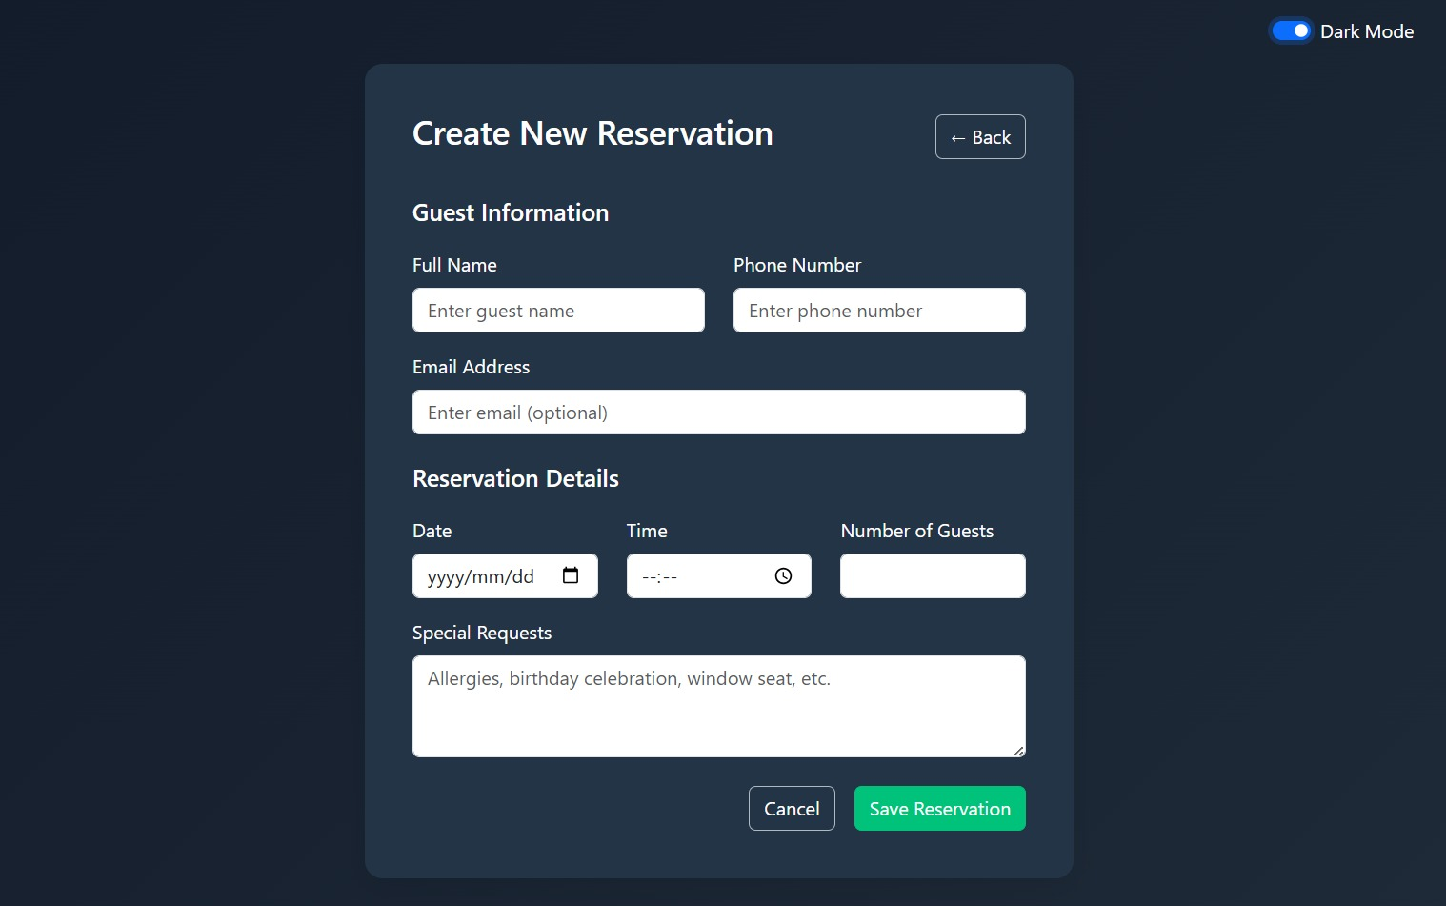 New Reservation Dark
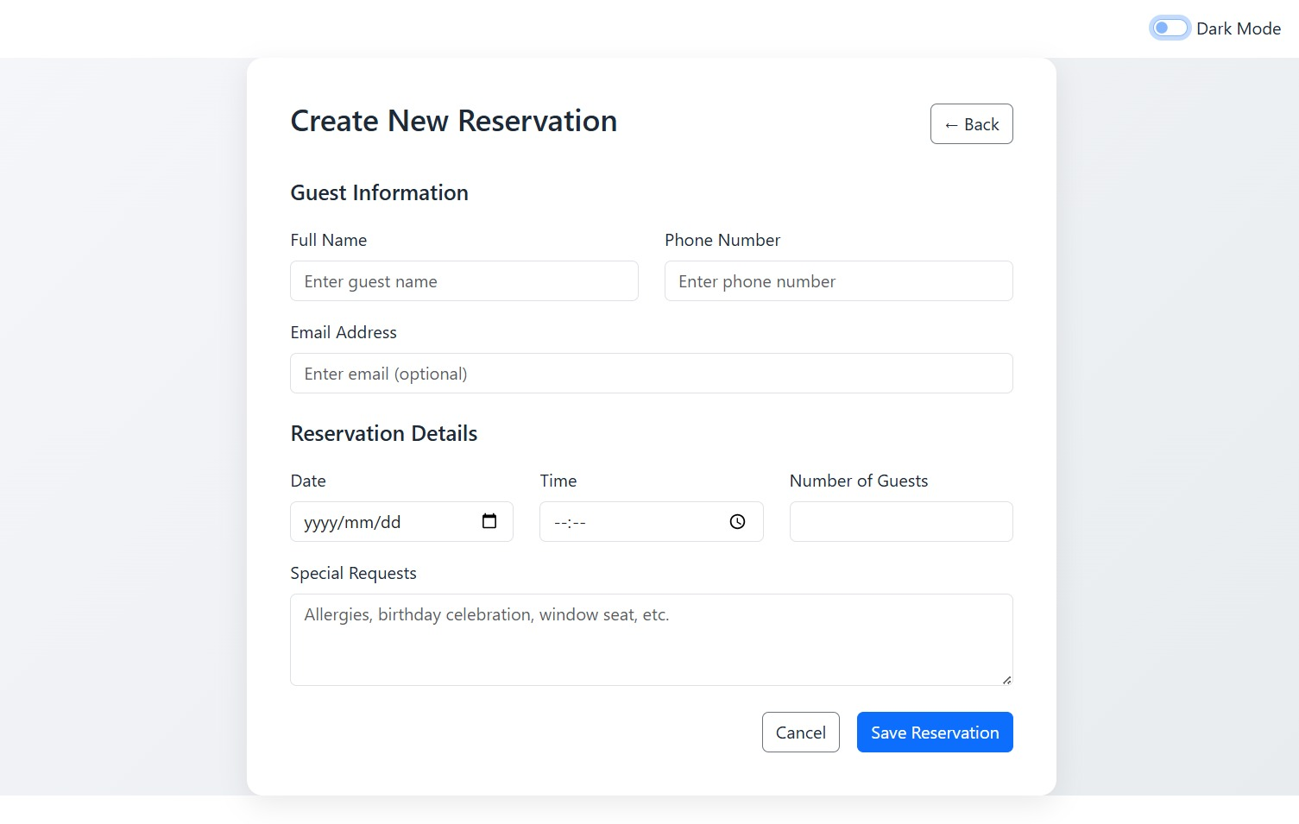New Reservation - Light
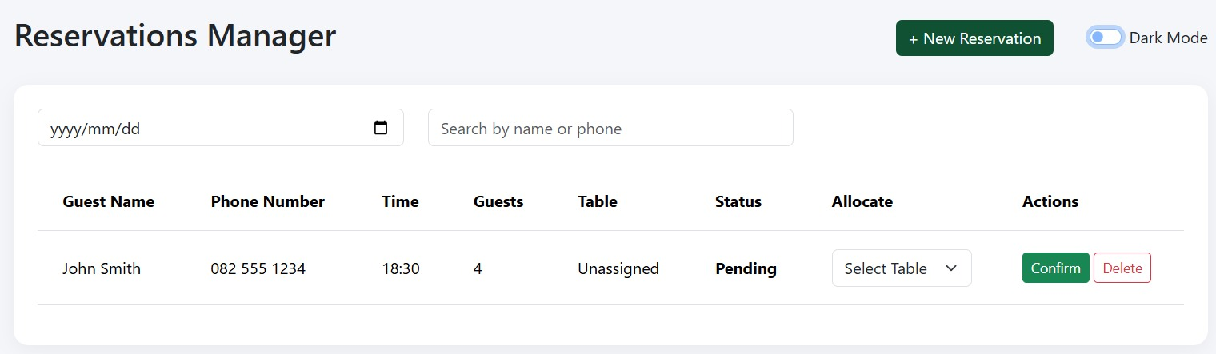Reservation Manager – Light
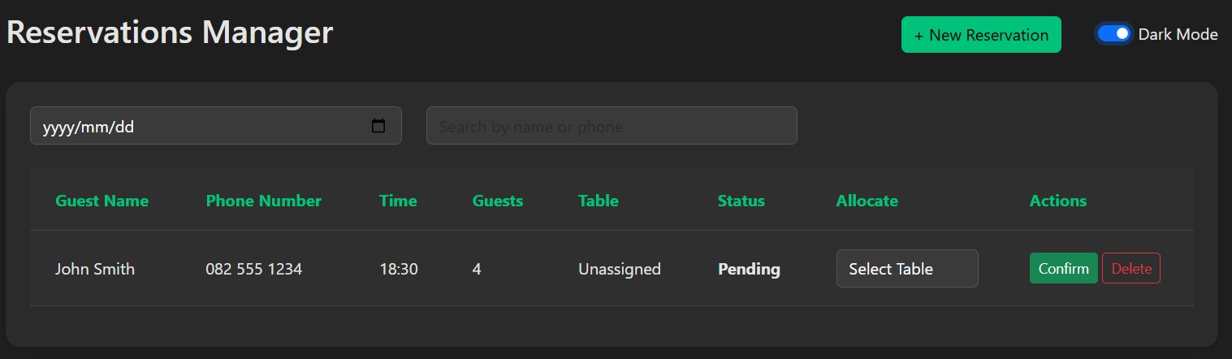
Reservation Manager – Dark
Key Features
- The New Reservation form is designed with user-friendliness in mind with separated sections for guest information and reservation details. Additionally, by leaving the form relatively undetailed, the space remains decluttered, reducing the chances of a user becoming overwhelmed.
- The Reservations Manager form serves as a central point for booking details. A date dropdown and search bar have been included for ease of use.

Sales Overview
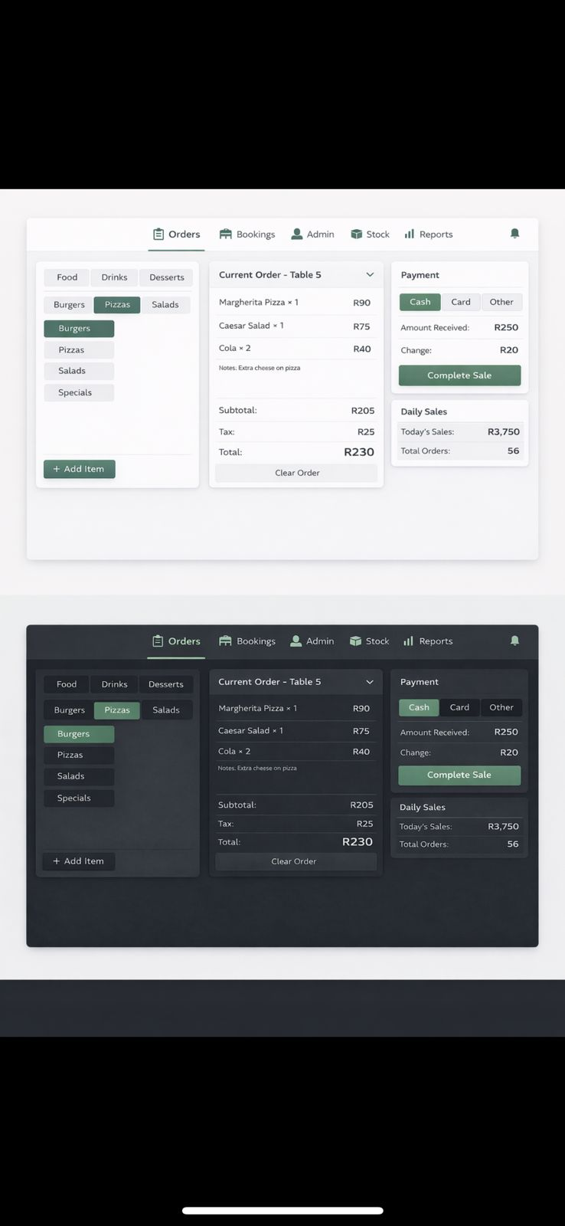
Sales Overview – Light & Dark
Key Features
- The Sales Overview dashboard is displayed as three information cards arranged chronologically in terms of order completion. Waitrons can make any final additions to the tab, before verifying the order details, and then finally completing the sale. Designing it in such a manner ensures a smooth user experience and reduces the chances of user error.

Manager Dashboard
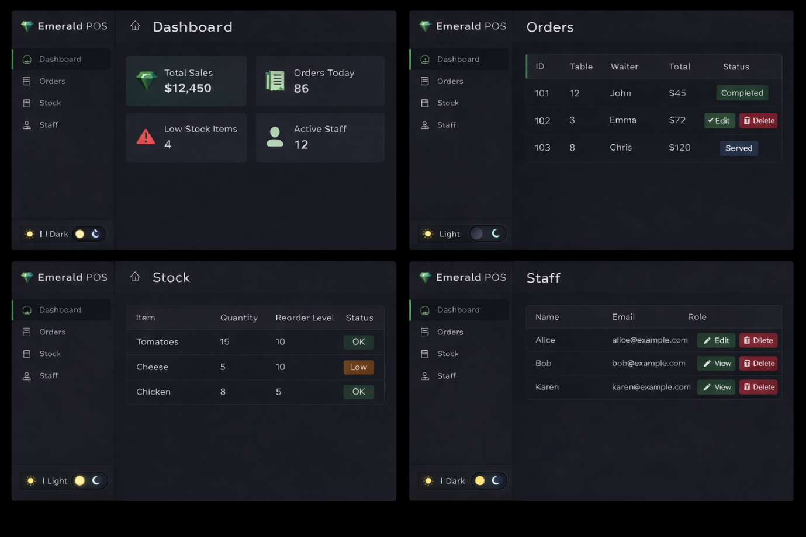
Compilation of Manager views – Dark
Key Features
- The Manager Portal contains four independent that allow managing staff to obtain business information or make any operational changes.
  - Upon logging in, a user is brought to the main Dashboard, which displays large information cards with basic, but crucial information.
  - Users may then select another tab in the menu alongside to view the orders completed, the stock level, and the staff employed and on duty.

Kitchen Portal
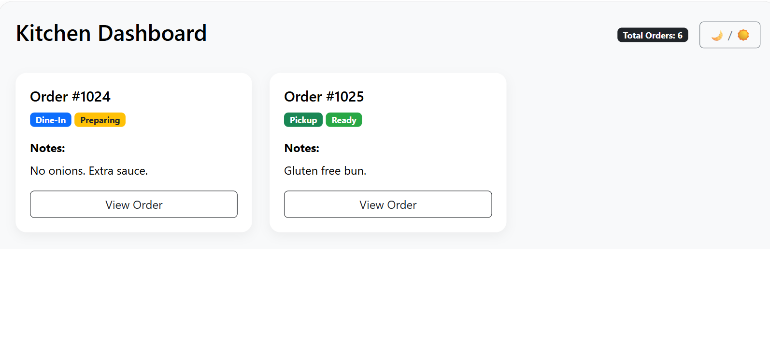Kitchen Dashboard – Light
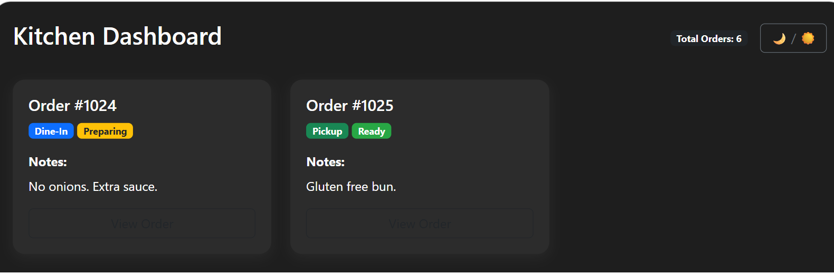Kitchen Dashboard – Dark
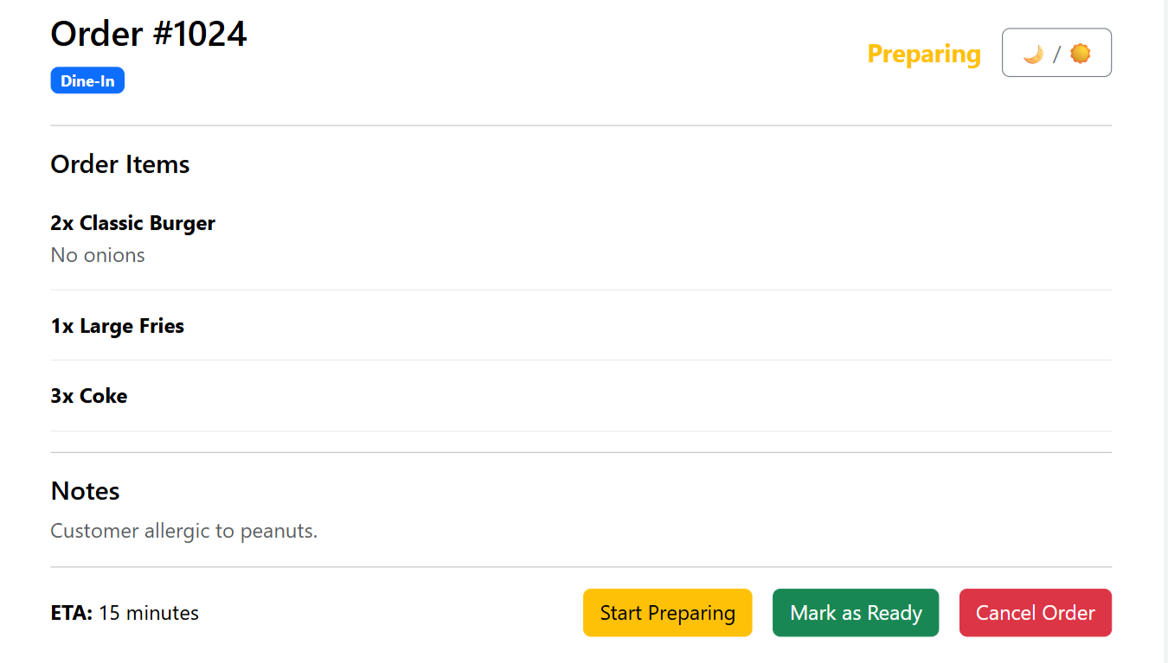Order Details – Light
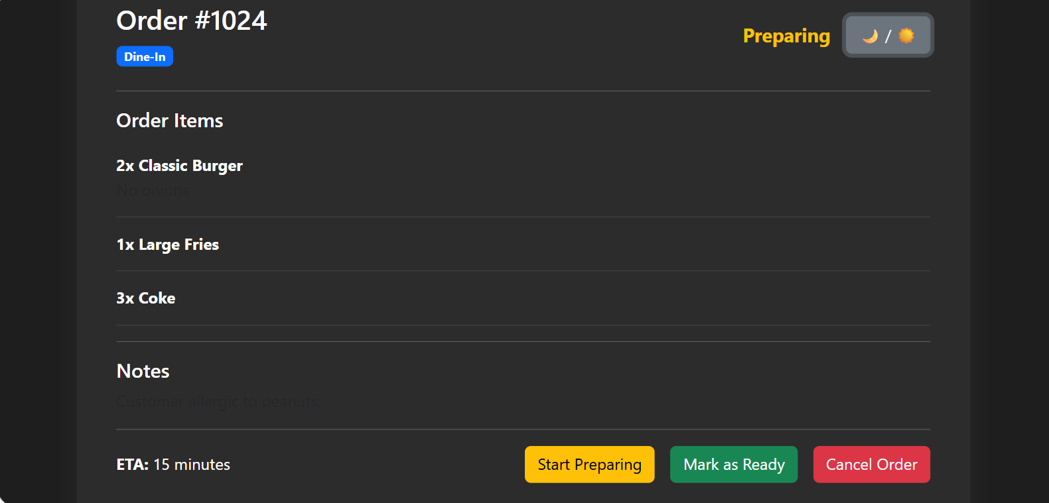Order Details – Dark
Key Features
- The Order Dashboard provides large cards displaying the order number, colour-logged tags, such as the order type and stage of preparation, as well as any extra notes intended for the kitchen.
- The Order Details view displays the items within each order as well as any other details pertaining to it. Additionally, the screen features easy-to-read action buttons to reduce the chance of user error.

